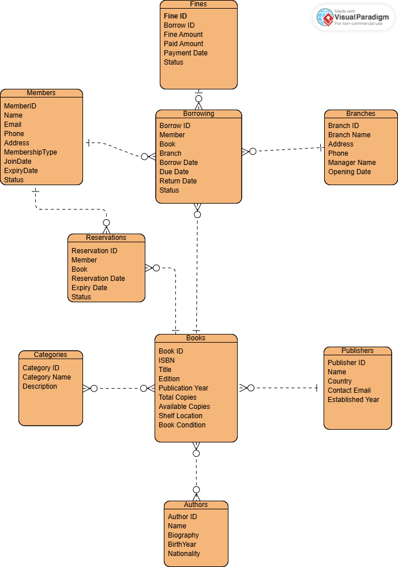
Task 1: ERD Design

Task 2: Normalization

 | Issues | Example
1NF | repeating values | author_names = "Alice Smith, Bob Jones" → two authors in one cell  categories = "Fiction, Drama" → two genres in one cell
2NF | Partial dependency | member_name depends only on member_id
3NF | transitive dependencies | publisher_country depends on publisher_name, not on the table key.

Task 3: Database Mapping
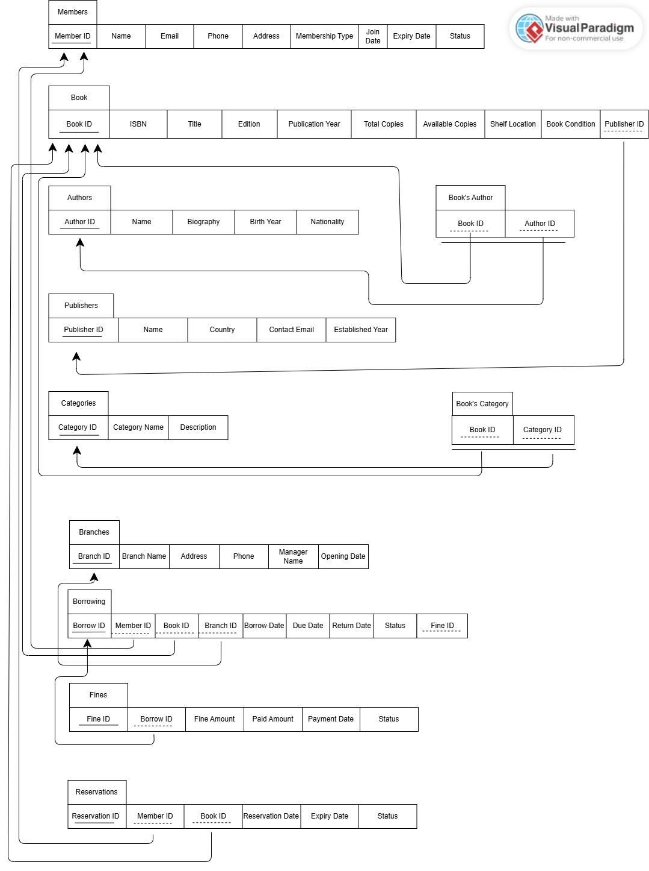

Task 6: SQL DQL - Basic Queries

- List all books published after 2020
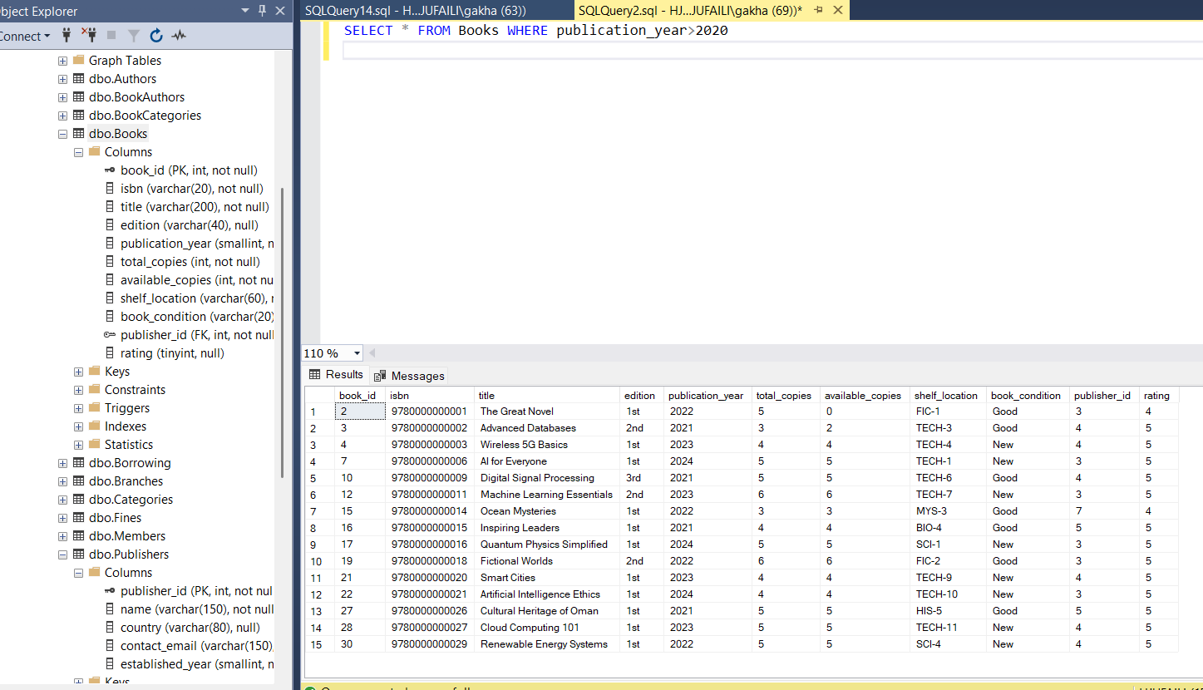

- Find all members whose membership expires in the next 30 days
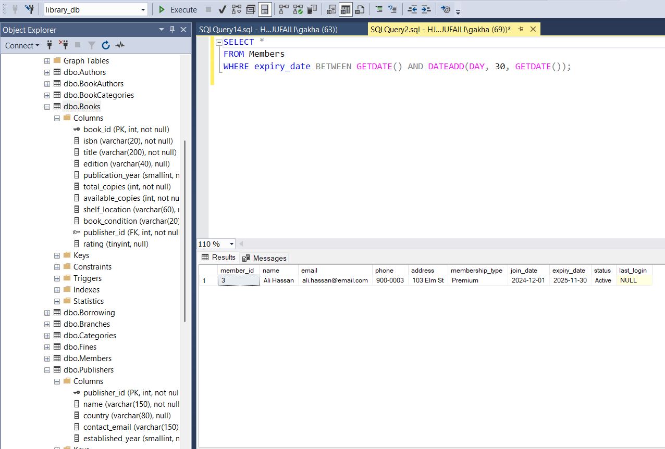
- Show all overdue borrowings (return_date IS NULL AND due_date < CURDATE())
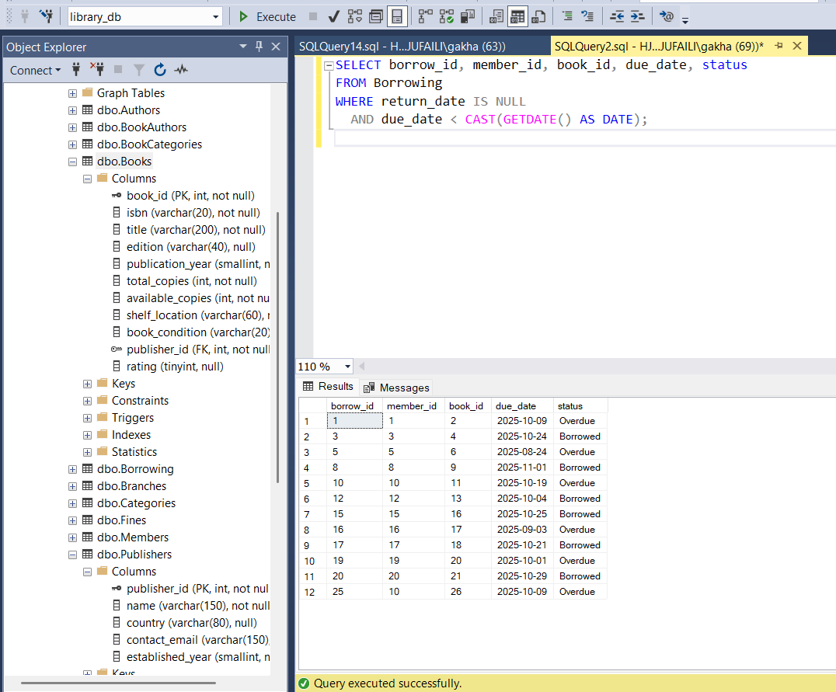

- List books that have never been borrowed
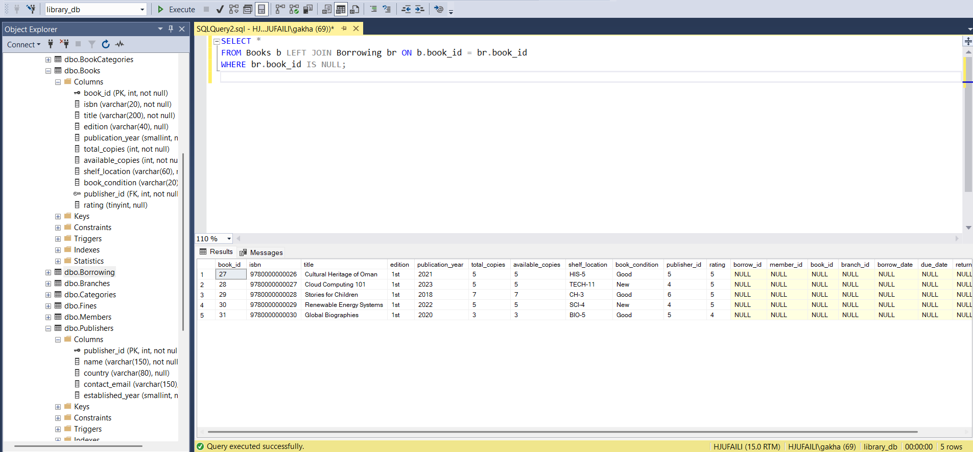

- Find members with pending fines greater than $10
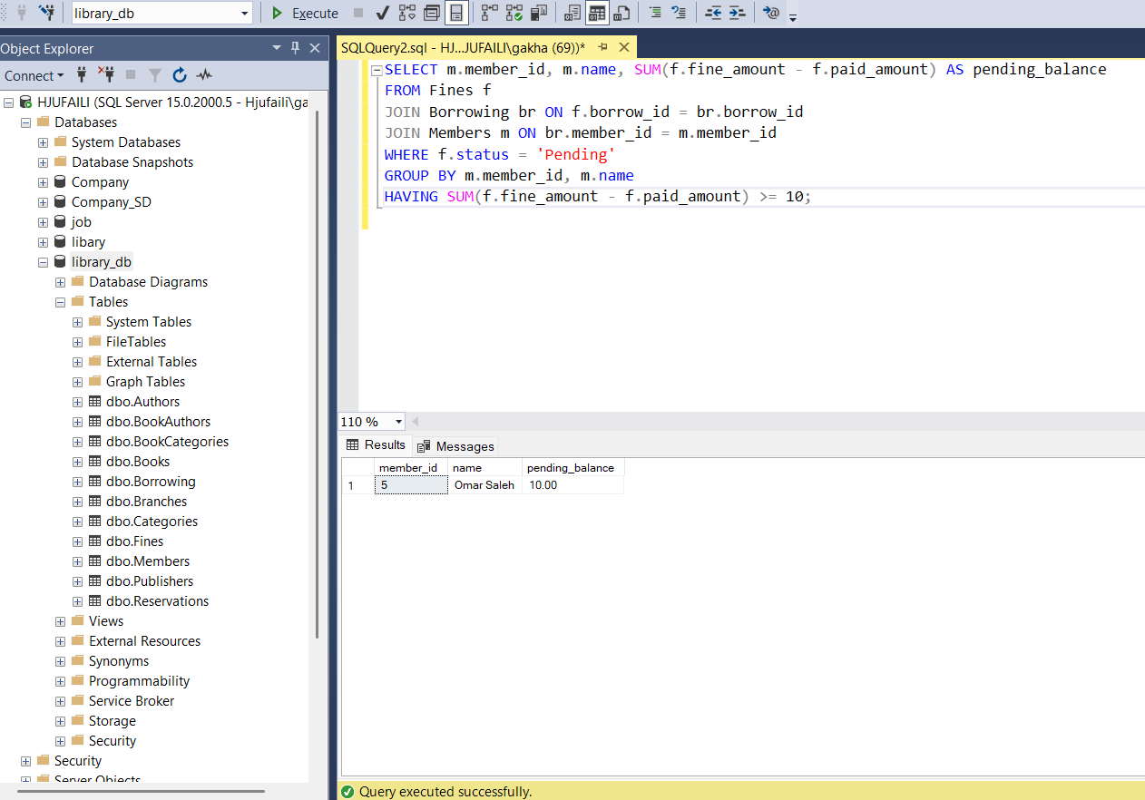

- Show all books in 'Fiction' category
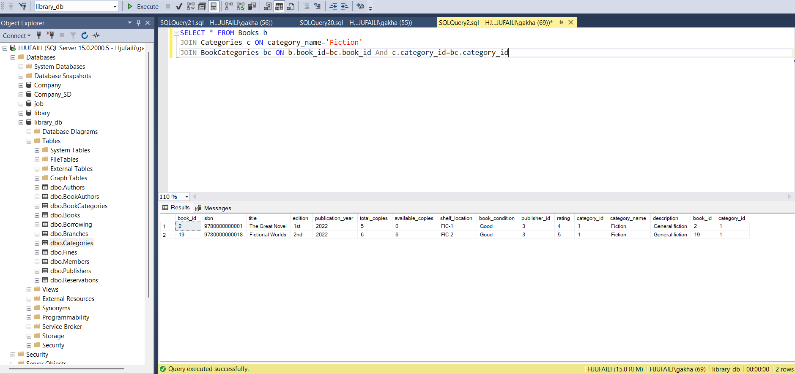

- Display books with less than 2 available copies
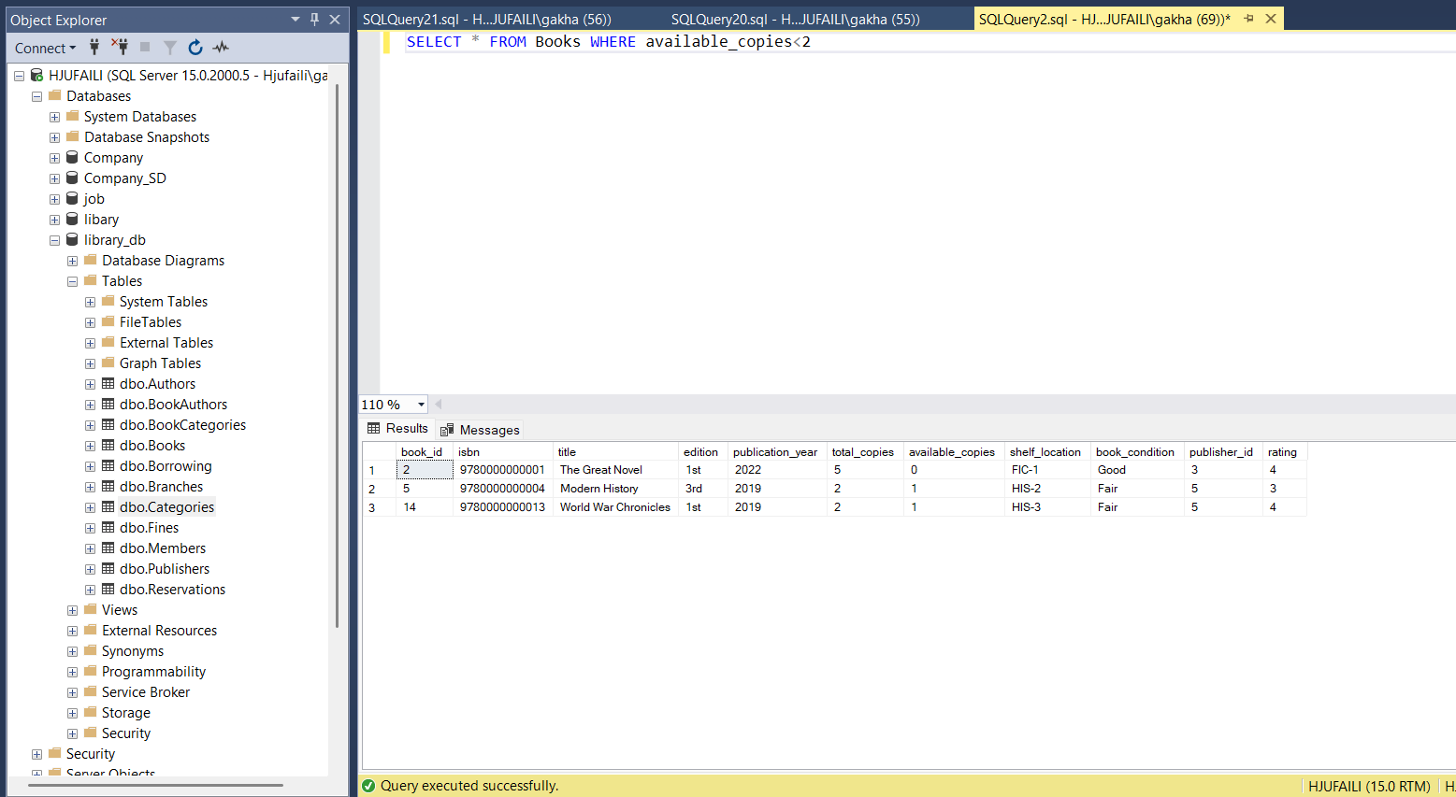

- List all authors from 'USA' or 'UK'
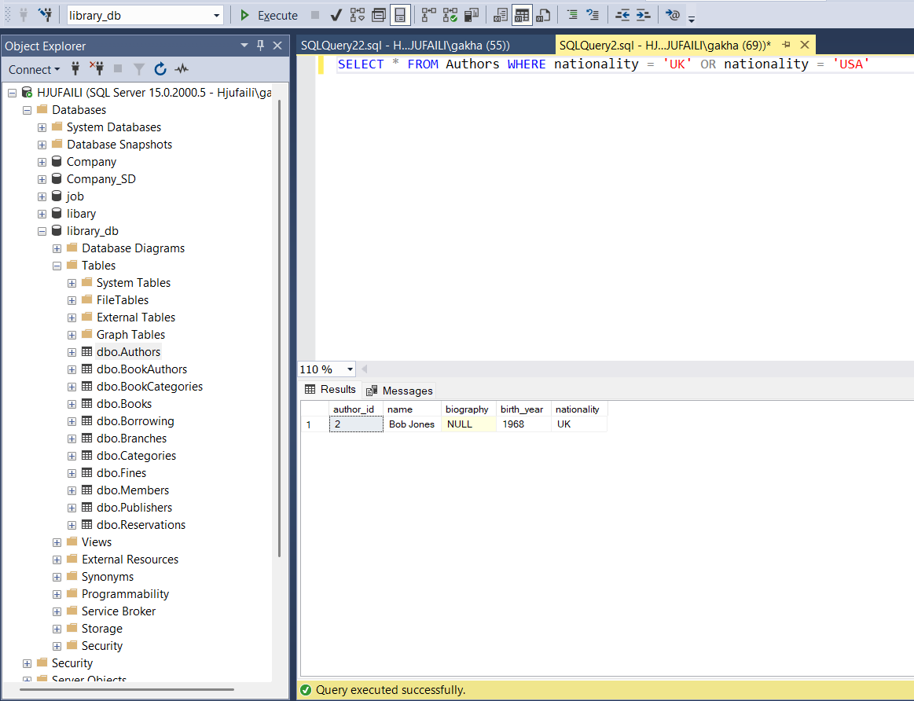

- Find books published by 'Penguin Random House'
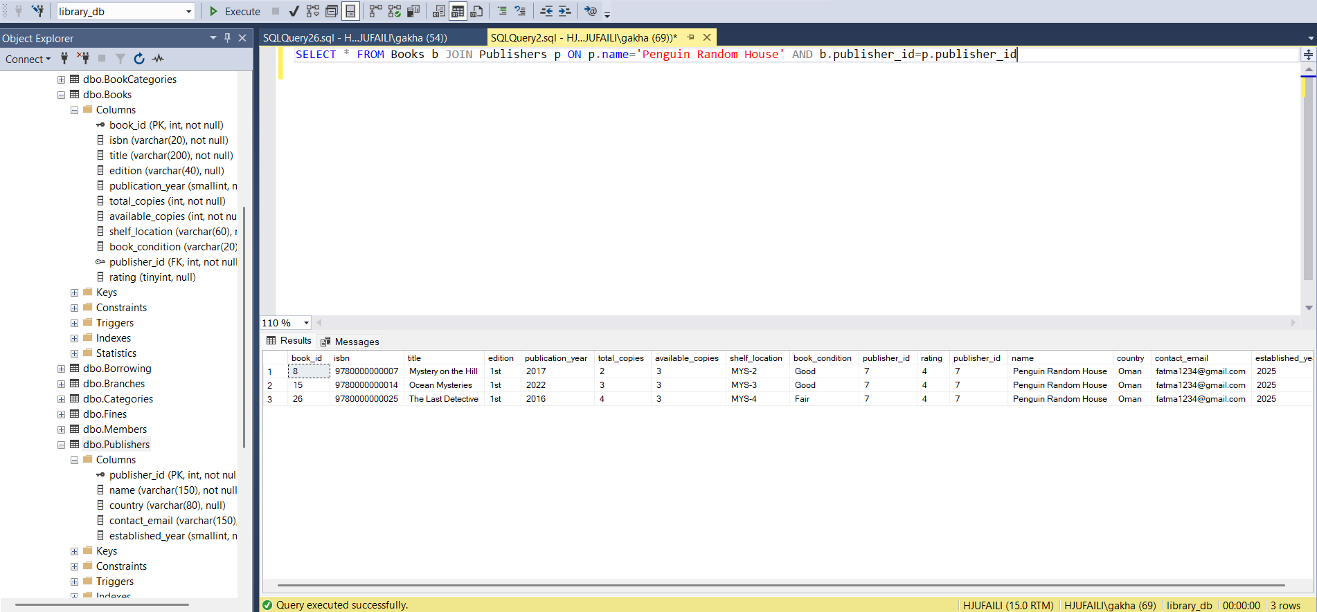

- Show borrowings from last month using BETWEEN
